Experiment No.:8 Date: / /

3-Bit UP-Down Counter
AIM: Write a VHDL code for 3-bit up down counter using sequential style of modeling.

EQUIPMENTS & COMPONENTS:
- Xilinx Vivado 14.5 Software / Modelsim Student Edition

Introduction
Counters are sequential logic circuits that, in digital electronics, are used to count the number of times an event or instance takes place.
A counter is made by cascading a series of flip-flops. As we know, flip-flops have a clock input. Depending on the type of clock input, counters are of two types
1. Asynchronous counter
2. Synchronous counter

1) Asynchronous Counter
In asynchronous counter we don’t use universal clock, only first flip flop is driven by main clock and the clock input of rest of the following counters is driven by output of previous flip flops.

2) Synchronous Counter
Unlike the asynchronous counter, synchronous counter has one global clock which drives each flip flop so output changes in parallel. The one advantage of synchronous counter over asynchronous counter is, it can operate on higher frequency than asynchronous counter as it does not have cumulative delay because of same clock is given to each flip flop.
Counters are used in many different applications. Some count up from zero and provide a change in state of output upon reaching a predetermined value; others count down from a preset value to zero to provide an output state change.
Well as their names imply, up counters count upwards or incrementally. Down counters count downwards or in a decremental manner. Up-down counters can count both upwards as well as downwards. A simple three-bit Up/Down synchronous counter can be built using JK flip-flops configured to operate as toggle or T-type flip-flops giving a maximum count of zero (000), advancing through 001, 010 to seven (111) and back to zero again.
Based on the way the counters are used, here are the various types of counters:
- Up counters
- Down counters
- Up-down counters
- Decade counter
- Ring counter
- Johnson counter

Difference between Synchronous and Asynchronous Counter:
Synchronous Counters | Asynchronous Counters
All flip-flops are given the same clock simultaneously | The flip-flops are not given the same clock
There is no connection between the output of a flip-flop and the clock input of the next flip-flop. | The output of a flip-flop is given as the clock input to the next flip-flop
The settling time is equal to the time it takes for the last flip-flop to get activated. This is quite less compared to the asynchronous counters. | The settling time or the time taken for all the flip-flops to get activated is equal to the sum of all the times needed to activate the last flip-flop.
It is known as a parallel counter | It is known as a serial counter
This design gets more complicated as the number of flip-flops increases | The design of asynchronous counters is easy
Synchronous counters are faster | Asynchronous counters are slower

VHDL Code for 3-bit Up/Down Counter:
library IEEE;
use IEEE.STD_LOGIC_1164.ALL;
use ieee.std_logic_arith.all;
use ieee.std_logic_unsigned.all;
entity counter3bit is
Port ( rst,clk,up_down : in STD_LOGIC;
count : out STD_LOGIC_VECTOR (0 to 2));
end counter4bit;
architecture Behavioral of counter4bit is
signal temp:std_logic_vector(0 to 2);
begin
p1:process(rst,clk,up_down)
begin
if(rst='1') then
temp<="000";
elsif(clk='1' and clk'event) then
if(up_down='1') then
temp<=temp+1;
else
temp<=temp-1;
end if;
end if;
end process;
count<=temp;
end Behavioral;

RTL Schematic for 3-bit Up/Down Counter:
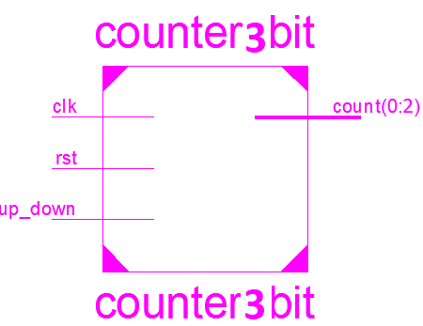
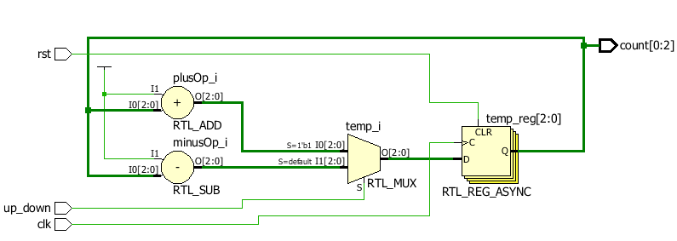
Simulation Result for Up Counting:
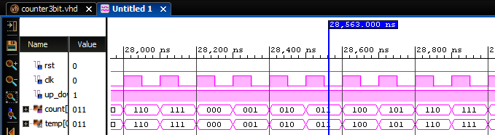
Simulation Result for Down Counting:
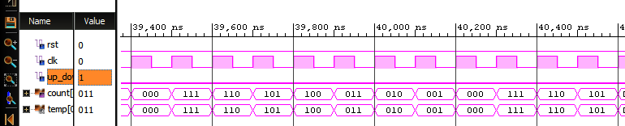
CONCLUSION: 3-Bits binary Up/Down counter has been studied. VHDL code for the same is written and functionality is verified with the help of Xilinx Vivado 14.5 Software.

